Sequencial And Collaboration Diagram Of Ordering System
Institution Affiliation:
Student’s Name:

Ordering System
Having reviewed how a Buyer Seller system works, it is now appropriate to narrow down to the ordering system and understand how everything operates, from placing an order to delivery. An ordering system are inventory managing systems, that captures the customers requests and processes deliver internally from the sellers. With our subject company e- Market, the system is online. The system involves less physical contact making it flexible to operate it any where in the world.
Class Diagrams
With the diagrams, one gets to know how various groups of objects collaborate over time to result in to a functioning body. The setup is controlled by communication, entities in the system only work when they are instructed to. In order to control the traffic of information passed on to the order system, the actions are dependent on each other where none can function incase one fails or misses to respond.
There are basic notations that add up to the sequence diagram and the collaboration diagrams, namely Objects and Message. In other instance one can include character models (actors) to represent humans. The objects are the different classes in the form of rectangles, while the messages are the information passed between classes. In our case, the ordering sytem can be summarized as shown below.

Sequence Diagram
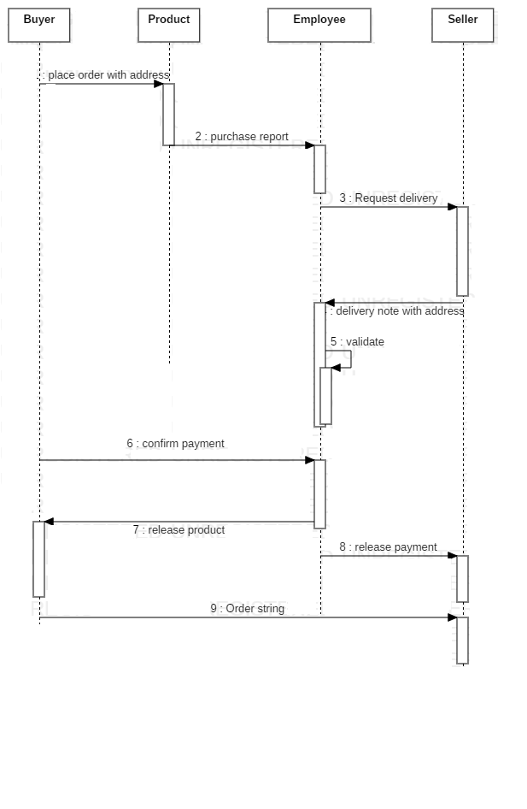

Collaboration Diagram
